



**PROJECT REPORT**

|  |  |
| --- | --- |
| Project Name | Travel Smart |
| Project Title | AstroRoam |
| Project by | ThyError404 |

AstroRoam

Index

Acknowledgement

in preparation towards this project , we had to get, advice and guidance towards our Respected teacher Mr. Ashish who has help us in preparation towards completing this project from the TechWiz 5

* ThyError404

Project Synopsis

while planning for our own trip can be a joyful occasion that can only be applied for certain amount of people it takes more that 2 week to properly plan an wonderful and relaxing vacation or trip which can be very exhausting for most people and which is why travel Website such as AstroRoam is very beneficial to those who would like to immediately go to a vacation or tourist spot with only a slight increase in the payment the website can offer package which will not only offer the best tourist spot but also the safest

Scope

This Web portal must be a responsive and visually appealing Webpage to be used by individuals. This portal must be designed to enable users to browse through and select packages that is available or inquire certain benefits from other packages then they are more than welcome to inquire in the inquiry section

Proposed Solution

The purpose of this webpage is to save people from the countless hours spending on planning on vacation and this webpage might be able to offer people trip to which they have never gone before

AstroRoam consists of six main section.

1. Home
2. About
3. Services
4. Packages
5. Contact
6. Reviews

Site Map

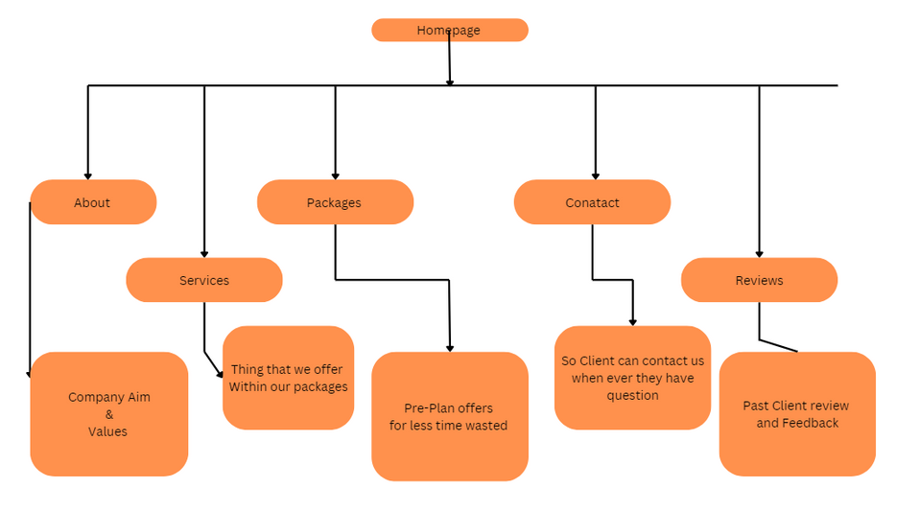

Homepage

Here, Users will be welcome with the webpage and will be able to see the nav bar which ill include the 6 main section of the webpage

one the home section there will be 2 button as the user press the contact us they will be moves to the contact section and as the user press on the learn more they will be moved to the package section

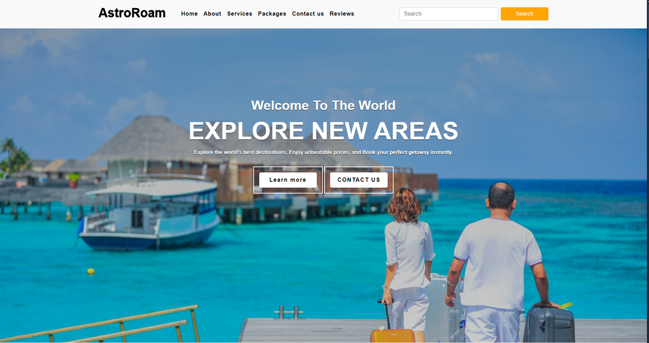

About Section

here user will be introduced to on what are the aims of the webpage AstroRoam, whether the client wants to hike through the mountains exploring vibrant cities, or stargazing in remote locations, the Webpage AstroRoam aims to guide user or client through their journey. We curate travel guides, share personal stories, and offer expert advice to help you roam the world with confidence.

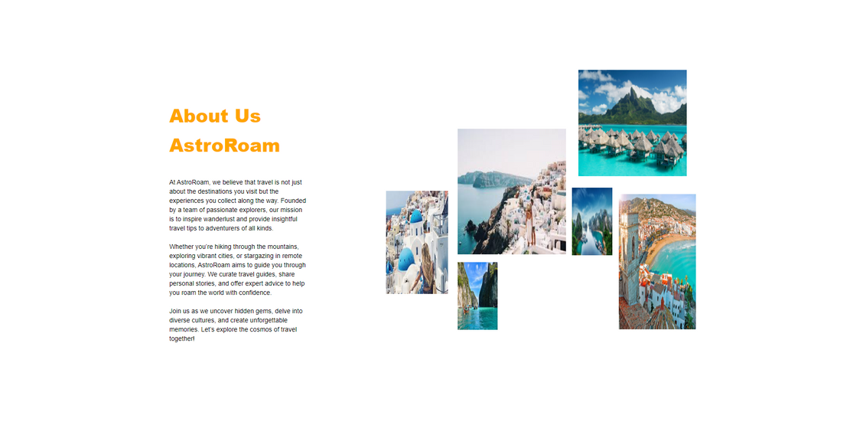

Services section

in this Section user will be able to see what type of services are included within their packages

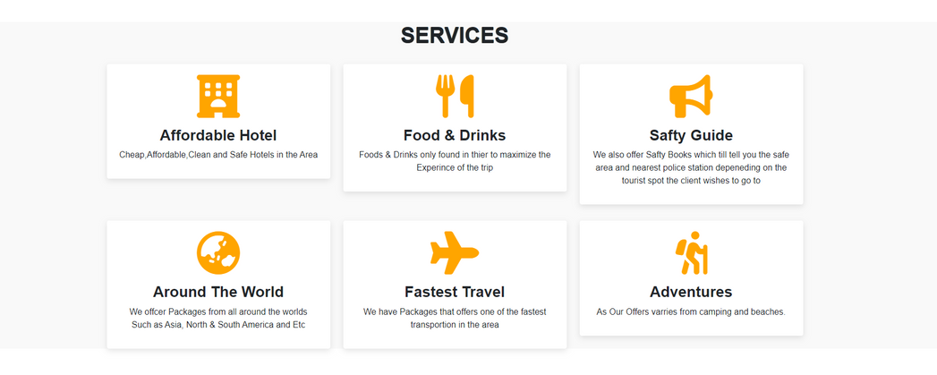

And Of course if the user or client need more specialized services they are more then welcome to message us through the inquire trip planner or trough out official email

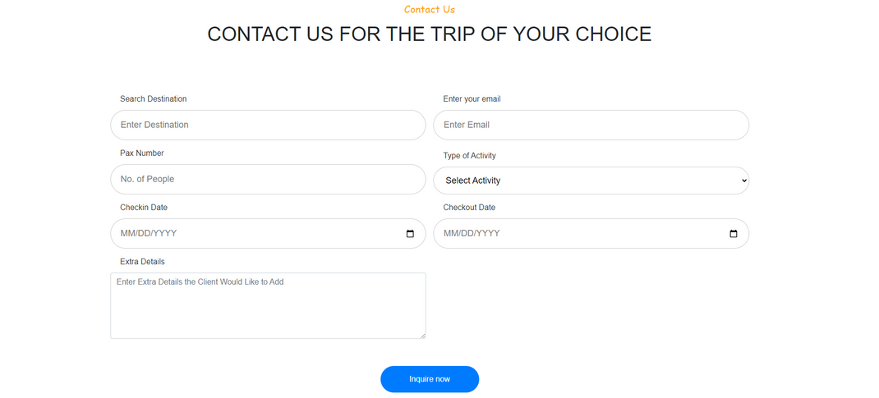

in this section user will be able to inquire or plan their own trip and once the area has been filled there will be a pop up message stating that their inquires will be sent to our available agent

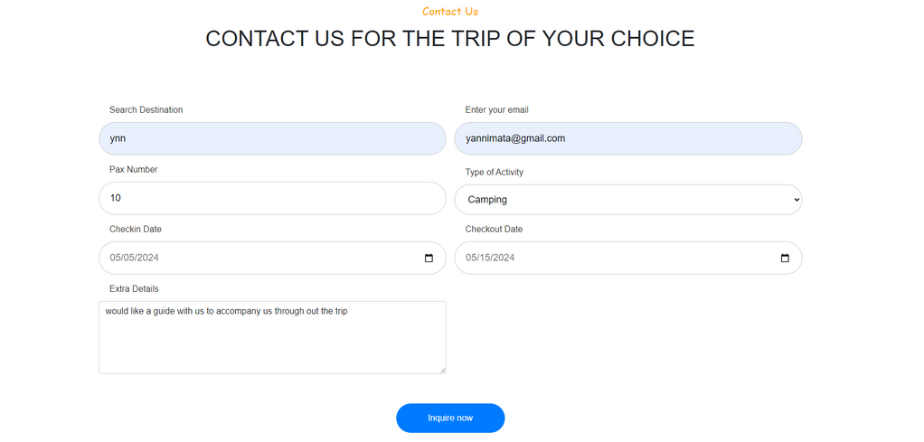

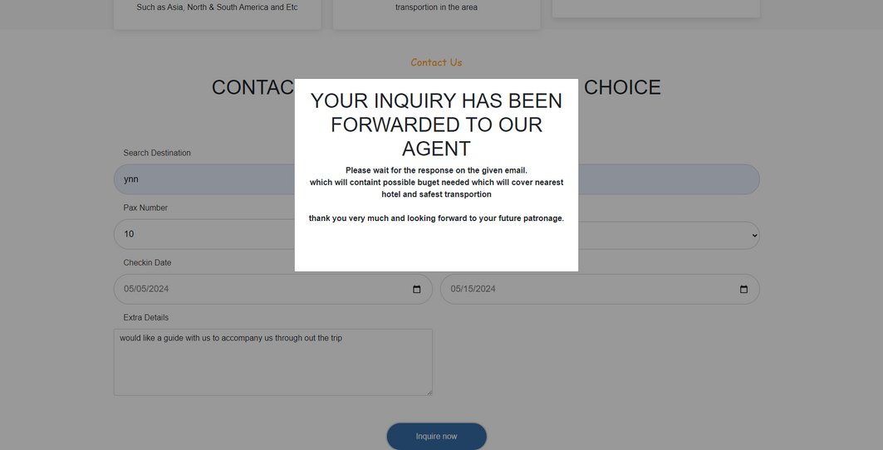

Package Section

In this Section of the Webpage the users will be offered pre-planned packages they show how many have gotten the package and how much will will have to play this section will also tell users how many people are able to join within the package however the price may vary

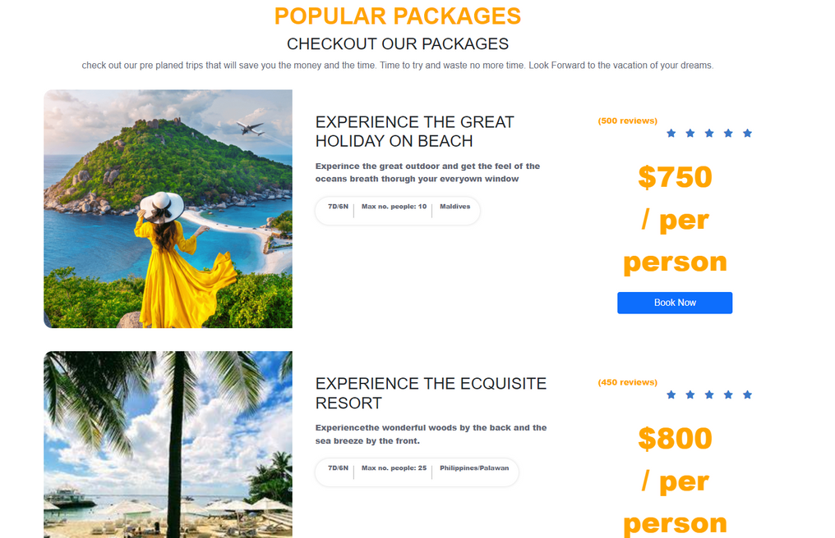

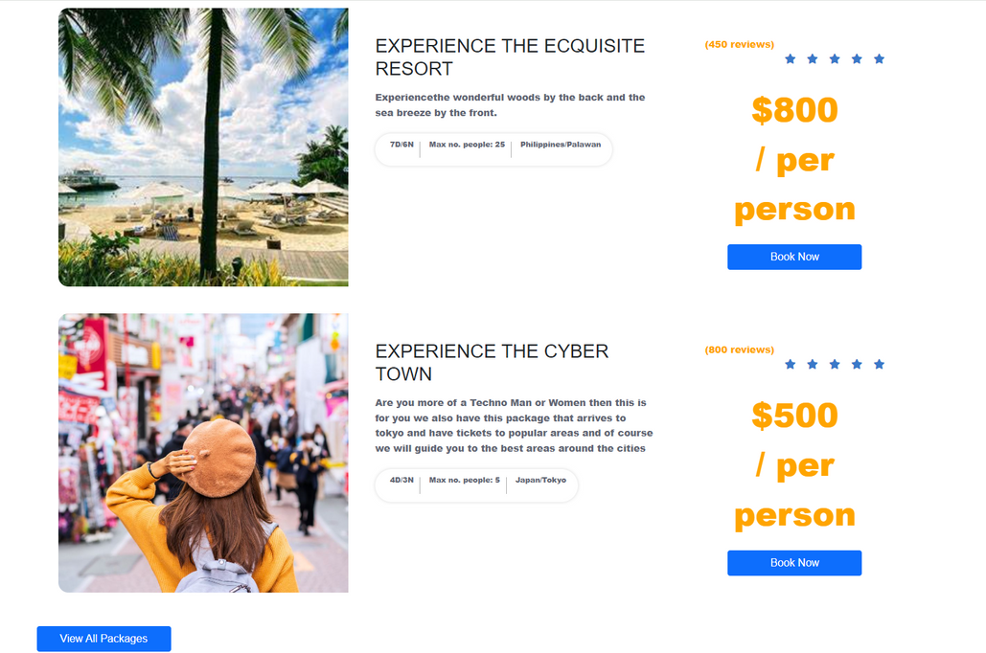

on the the bottom of this package section there will be a button which will open us other offers ideally they will be redirected to a page full of offers but this will be worked on in the near future

Contact Us Section

in this section it will only show the user emails where the users can contact developers



Client Reviews Section

in this section the user will be shown feedback from people who have bought packages through our webpage to help encourage others to trust our webpage that it is safe secured and fast

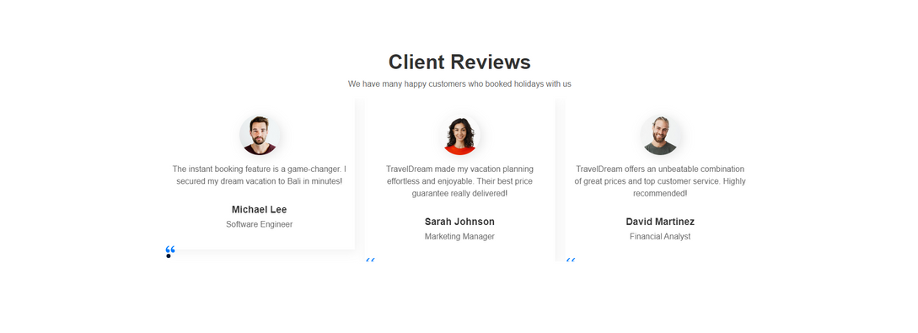

Footer Section

in this section the user will just be shown to the Title AstroRoam and some of the social media icon which is supposed to redirect user to the social media icon they have pressed

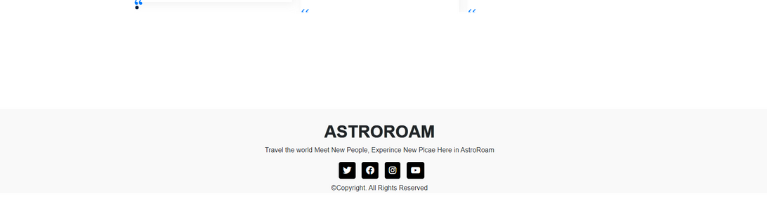

This website is built with the help of three programming languages and five open-source libraries.

Programming Languages:

1. HTML5
2. CSS
3. JavaScript

Open-Source Technologies Used:

1. Bootstrap v5.0.2(Bootstrap.mini.css)
2. JavaScript(https://unpkg.com/swiper/swiper-bundle.min.css – for the client review)
3. Font Awesome ("https://cdnjs.cloudflare.com/ajax/libs/font-awesome/6.0.0-beta3/css/all.min.css") ("https://cdnjs.cloudflare.com/ajax/libs/font-awesome/6.2.1/css/all.min.css")(”https://cdn.jsdelivr.net/npm/remixicon@4.3.0/fonts/remixicon.css)

Features:

* Latest browser compatibility
* Doesn’t need an internet connection to test the site (all required sources are locally saved.)
* Testing the site is super easy

Software used to write the code:

* Visual Studio Code

Source Code

HTML

[ General / Common on All Pages ]

1. The Head Tag

<head>

    <meta charset="UTF-8">

    <meta name="viewport" content="width=device-width, initial-scale=1.0">

    <title>ThyError404 Team TravelSmart </title>

    <!--My Css -->

    <link rel="stylesheet" href="style.css">

    <!--My Css -->

    <!-- Bootstrap Link -->

    <link  rel="stylesheet" href="https://cdn.jsdelivr.net/npm/bootstrap@5.0.2/dist/css/bootstrap.min.css">

    <!-- Bootstrap Link -->

    <!--Java Script Link-->

    <link rel="stylesheet" href="https://unpkg.com/swiper/swiper-bundle.min.css" />

    <!--Java Script Link-->

    <!-- Font Awesome Cdn -->

    <link rel="stylesheet" href="https://cdn.jsdelivr.net/npm/remixicon@4.3.0/fonts/remixicon.css" >

    <link rel="stylesheet" href="https://cdnjs.cloudflare.com/ajax/libs/font-awesome/6.0.0-beta3/css/all.min.css">

    <link rel="stylesheet" href="https://cdnjs.cloudflare.com/ajax/libs/font-awesome/6.2.1/css/all.min.css">

    <!-- Font Awesome Cdn -->

</head>

1. The Navigation Bar

<!--navbar-->

<section>

    <nav class="navbar navbar-expand-lg" id="navbar">

        <div class="container">

          <a class="navbar-brand" href="index.html" id="logo">AstroRoam</a>

          <button class="navbar-toggler" type="button" data-bs-toggle="collapse" data-bs-target="#mynavbar">

            <i class="fa-solid fa-bars"></i>

          </button>

          <div class="collapse navbar-collapse" id="mynavbar">

            <ul class="navbar-nav me-auto">

              <li class="nav-item">

                <a class="nav-link active" href="#home">Home</a>

              </li>

              <li class="nav-item">

                <a class="nav-link" href="#about">About</a>

              </li>

              <li class="nav-item">

                <a class="nav-link" href="#services">Services</a>

              </li>

              <li class="nav-item">

                <a class="nav-link" href="#package">Packages</a>

              </li>

              <li class="nav-item">

                <a class="nav-link" href="#contact">Contact us</a>

              </li>

              <li class="nav-item">

                <a class="nav-link" href="#client">Reviews</a>

              </li>

            </ul>

            <form class="d-flex">

              <input class="form-control me-2" type="text" placeholder="Search">

              <button class="btn btn-primary" type="button">Search</button>

            </form>

          </div>

        </div>

      </nav>

</section>

2. Home Section

<!--Home-->

<section id="home">

    <div class="home">

        <div class="content">

            <h5>Welcome To The World</h5>

            <h1>Explore New Areas</h1>

            <p>Explore the world's best destinations, Enjoy unbeatable prices, and Book your perfect getaway instantly.</p>

            <div>

                <button type="button"><a class="nav-link" href="#package"><span></span>Learn more</a></button>

                <button type="button"><a class="nav-link" href="#contact"><span></span>CONTACT US</a></button>

            </div>

        </div>

    </div>

</section>

3. About us Section

<!--About us-->

<div class="responsive-container-block bigContainer" id="about"></div>

  <div class="responsive-container-block Container">

    <div class="responsive-container-block leftSide">

      <p class="text-blk heading">

        About Us AstroRoam

      </p>

      <p class="text-blk subHeading">

        At AstroRoam, we believe that travel is not just about the destinations you visit but the experiences you collect along the way. Founded by a team of passionate explorers, our mission is to inspire wanderlust and provide insightful travel tips to adventurers of all kinds.

      <br><br>

      Whether you’re hiking through the mountains, exploring vibrant cities, or stargazing in remote locations, AstroRoam aims to guide you through your journey. We curate travel guides, share personal stories, and offer expert advice to help you roam the world with confidence.

      <br><br>

      Join us as we uncover hidden gems, delve into diverse cultures, and create unforgettable memories. Let’s explore the cosmos of travel together!

      </p>

    </div>

    <div class="responsive-container-block rightSide">

      <img class="number1img" src="images/photo1.jpeg">

      <img class="number2img" src="images/photot2.jpeg">

      <img class="number3img" src="images/photo3.jpeg">

      <img class="number5img" src="images/photo4.webp">

      <img class="number7img" src="images/photo5.jpg">

      <img class="number6img" src="images/photo6.jpg">

    </div>

  </div>

</div>

4. Services Section

<!--Services-->

<section class="services" id="services">

        <div class="container">

          <div class="main-txt">

            <h1>Services</h1>

          </div>

          <div class="row" style="margin-top: 30px;">

            <div class="col-md-4 py-3 py-md-0">

              <div class="card">

                <i class="fas fa-hotel"></i>

                <div class="card-body">

                  <h3>Affordable Hotel</h3>

                  <p>Cheap,Affordable,Clean and Safe Hotels in the Area</p>

                </div>

              </div>

            </div>

            <div class="col-md-4 py-3 py-md-0">

              <div class="card">

                <i class="fas fa-utensils"></i>

                <div class="card-body">

                  <h3>Food & Drinks</h3>

                  <p>Foods & Drinks only found in thier to maximize the Experince of the trip</p>

                </div>

              </div>

            </div>

            <div class="col-md-4 py-3 py-md-0">

              <div class="card">

                <i class="fas fa-bullhorn"></i>

                <div class="card-body">

                  <h3>Safty Guide</h3>

                  <p>We also offer Safty Books which till tell you the safe area and nearest police station depeneding on the tourist spot the client wishes to go to</p>

                </div>

              </div>

            </div>

          </div>

          <div class="row" style="margin-top: 30px;">

            <div class="col-md-4 py-3 py-md-0">

              <div class="card">

                <i class="fas fa-globe-asia"></i>

                <div class="card-body">

                  <h3>Around The World</h3>

                  <p>We offcer Packages from all around the worlds<br>

                  Such as Asia, North & South America and Etc</p>

                </div>

              </div>

            </div>

            <div class="col-md-4 py-3 py-md-0">

              <div class="card">

                <i class="fas fa-plane"></i>

                <div class="card-body">

                  <h3>Fastest Travel</h3>

                  <p>We have Packages that offers one of the fastest transportion in the area</p>

                </div>

              </div>

            </div>

            <div class="col-md-4 py-3 py-md-0">

              <div class="card">

                <i class="fas fa-hiking"></i>

                <div class="card-body">

                  <h3>Adventures</h3>

                  <p>As Our Offers varries from camping and beaches.</p>

                </div>

              </div>

            </div>

          </div>

        </div>

      </section

6.Tour Search/ trip inquiry section

<!--Tour Search bar-->

<section class="tour-search" id="tour">

  <div class="container">

    <div class="container-xxl py-5">

      <div class="container">

          <div class="text-center wow fadeInUp" data-wow-delay="0.1s">

              <h5 class="section-title ff-secondary text-center text-orange fw-normal">Contact Us</h5>

              <h1 class="mb-5">CONTACT US FOR THE TRIP OF YOUR CHOICE</h1>

          </div>

      </div></div>

      <form action="" class="tour-search-form">

          <div class="input-wrapper">

              <label for="destination" class="input-label">Search Destination</label>

              <input type="text" name="destination" id="destination" required placeholder="Enter Destination" class="input-field">

          </div>

          <div class="input-wrapper">

              <label for="email" class="input-label">Enter your email</label>

              <input type="email" name="email" id="email" required placeholder="Enter Email" class="input-field">

          </div>

          <div class="input-wrapper">

              <label for="people" class="input-label">Pax Number</label>

              <input type="number" name="people" id="people" required placeholder="No. of People" class="input-field" min="1">

          </div>

          <div class="input-wrapper">

              <label for="Activity" class="input-label">Type of Activity</label>

              <select name="Activity" id="Activity" required class="input-field">

                  <option value="" disabled selected>Select Activity</option>

                  <option value="hiking">Hiking</option>

                  <option value="adventure">Camping</option>

                  <option value="sightseeing">Sightseeing</option>

                  <option value="adventure">Adventure</option>

                  <option value="others">others</option>

              </select>

          </div>

          <div class="input-wrapper">

              <label for="checkin" class="input-label">Checkin Date</label>

              <input type="date" name="checkin" id="checkin" required class="input-field">

          </div>

          <div class="input-wrapper">

              <label for="checkout" class="input-label">Checkout Date</label>

              <input type="date" name="checkout" id="checkout" required class="input-field">

          </div>

          <div class="input-wrapper">

              <label for="extra-details" class="input-label">Extra Details</label>

              <textarea class="form-control" rows="5" name="extra-details" placeholder="Enter Extra Details the Client Would Like to Add"></textarea>

          </div>

          <div class="input-wrapper button-wrapper">

              <button type="submit" class="btn btn-secondary">Inquire now</button>

          </div>

      </form>

      <div id="myPopup" class="popup" style="display:none;">

          <div class="popup-content text-center">

              <h1>Your Inquiry Has Been Forwarded to Our Agent</h1>

              <p>Please wait for the response on the given email.<br>

              which will containt possible buget needed which will cover nearest hotel and safest transportion

            <br><br>thank you very much and looking forward to your future patronage.</p>

              <button id="closePopup">Close</button>

          </div>

      </div>

  </div>

</section>

7.Package Section

<!--Products offers/Packages-->

<section class="package" id="package">

  <div class="container">

    <h1 class="section-subtitle">Popular Packages</h1>

    <h3 class="h3 section-title">Checkout Our Packages</h3>

    <p class="section-text">

      check out our pre planed trips that will save you the money and the time. Time to try and waste no more time. Look Forward to the vacation of your dreams.

    </p>

    <ul class="package-list">

      <li>

        <div class="package-card">

          <figure class="card-banner">

            <img src="images/vaca-product-1.webp" alt="Experience The Great Holiday On Beach" loading="Beach">

          </figure>

          <div class="card-content">

            <h3 class="h3 card-title">Experience The Great Holiday On Beach</h3>

            <p class="card-text">

              Experince the great outdoor and get the feel of the oceans breath thorugh your everyown window

            </p>

            <ul class="card-meta-list">

              <li class="card-meta-item">

                <div class="meta-box">

                  <ion-icon name="time"></ion-icon>

                  <p class="text">7D/6N</p>

                </div>

              </li>

              <li class="card-meta-item">

                <div class="meta-box">

                  <ion-icon name="people"></ion-icon>

                  <p class="text">Max no. people: 10</p>

                </div>

              </li>

              <li class="card-meta-item">

                <div class="meta-box">

                  <ion-icon name="location"></ion-icon>

                  <p class="text">Maldives</p>

                </div>

              </li>

            </ul>

          </div>

          <div class="card-price">

            <div class="wrapper">

                <p class="reviews">(500 reviews)</p>

                <div class="star">

                    <i class="fa-solid fa-star checked"></i>

                    <i class="fa-solid fa-star checked"></i>

                    <i class="fa-solid fa-star checked"></i>

                    <i class="fa-solid fa-star"></i>

                    <i class="fa-solid fa-star"></i>

                </div>

            </div>

            <p class="price">

                $750<br>

                / per person

            </p>

            <button class="btn btn-primary">Book Now</button>

        </div>

        </div>

      </li>

      <!--Package 2 -->

      <li>

        <div class="package-card">

          <figure class="card-banner">

            <img src="images/palawan-philip-pack.jpeg" alt="Experience The Great Holiday On Beach" loading="Beach">

          </figure>

          <div class="card-content">

            <h3 class="h3 card-title">Experience The Ecquisite Resort </h3>

            <p class="card-text">

              Experiencethe wonderful woods by the back and the sea breeze by the front.

            </p>

            <ul class="card-meta-list">

              <li class="card-meta-item">

                <div class="meta-box">

                  <ion-icon name="time"></ion-icon>

                  <p class="text">7D/6N</p>

                </div>

              </li>

              <li class="card-meta-item">

                <div class="meta-box">

                  <ion-icon name="people"></ion-icon>

                  <p class="text">Max no. people: 25</p>

                </div>

              </li>

              <li class="card-meta-item">

                <div class="meta-box">

                  <ion-icon name="location"></ion-icon>

                  <p class="text">Philippines/Palawan</p>

                </div>

              </li>

            </ul>

          </div>

          <div class="card-price">

            <div class="wrapper">

                <p class="reviews">(450 reviews)</p>

                <div class="star">

                    <i class="fa-solid fa-star checked"></i>

                    <i class="fa-solid fa-star checked"></i>

                    <i class="fa-solid fa-star checked"></i>

                    <i class="fa-solid fa-star"></i>

                    <i class="fa-solid fa-star"></i>

                </div>

            </div>

            <p class="price">

                $800<br>

                / per person

            </p>

            <button class="btn btn-primary">Book Now</button>

        </div>

        </div>

      </li>

  <!--Package 3-->

  <li>

    <div class="package-card">

      <figure class="card-banner">

        <img src="images/tokyo.jpg" alt="city" loading="city">

      </figure>

      <div class="card-content">

        <h3 class="h3 card-title">Experience the Cyber Town</h3>

        <p class="card-text">

          Are you more of a Techno Man or Women then this is for you we also have this package that arrives to tokyo and have tickets to popular areas and of course we will guide you to the best areas around the cities

        </p>

        <ul class="card-meta-list">

          <li class="card-meta-item">

            <div class="meta-box">

              <ion-icon name="time"></ion-icon>

              <p class="text">4D/3N</p>

            </div>

          </li>

          <li class="card-meta-item">

            <div class="meta-box">

              <ion-icon name="people"></ion-icon>

              <p class="text">Max no. people: 5</p>

            </div>

          </li>

          <li class="card-meta-item">

            <div class="meta-box">

              <ion-icon name="location"></ion-icon>

              <p class="text">Japan/Tokyo</p>

            </div>

          </li>

        </ul>

      </div>

      <div class="card-price">

        <div class="wrapper">

            <p class="reviews">(800 reviews)</p>

            <div class="star">

                <i class="fa-solid fa-star checked"></i>

                <i class="fa-solid fa-star checked"></i>

                <i class="fa-solid fa-star checked"></i>

                <i class="fa-solid fa-star"></i>

                <i class="fa-solid fa-star"></i>

            </div>

        </div>

        <p class="price">

            $500<br>

            / per person

        </p>

        <button class="btn btn-primary">Book Now</button>

    </div>

    </div>

  </li>

</ul>

<div class="input-wrapper button-wrapper">

<button class="btn btn-primary">View All Packages</button>

</div>

</div>

</section>

Contact Section

<!--contact-->

    <section id="contact">

      <div class="container-xxl py-5">

        <div class="container">

            <div class="text-center wow fadeInUp" data-wow-delay="0.1s">

                <h5 class="section-title ff-secondary text-center text-primary fw-normal">Contact Us</h5>

                <h1 class="mb-5">Contact For Any Query</h1>

            </div>

            <div class="row g-4">

                <div class="col-12">

                    <div class="row gy-4">

                        <div class="col-md-4">

                            <h5 class="section-title ff-secondary fw-normal text-start text-primary">Booking</h5>

                            <p><i class="fa fa-envelope-open text-primary me-2"></i>thyerror404@gmail.com/p>

                        </div>

                        <div class="col-md-4">

                            <h5 class="section-title ff-secondary fw-normal text-start text-primary">General</h5>

                            <p><i class="fa fa-envelope-open text-primary me-2"></i>thyerror404@gmail.com</p>

                        </div>

                        <div class="col-md-4">

                            <h5 class="section-title ff-secondary fw-normal text-start text-primary">Technical</h5>

                            <p><i class="fa fa-envelope-open text-primary me-2"></i>thyerror404@gmail.com</p>

                        </div>

                    </div>

                </div>

              </section>

Client Review Section

<!--Client Reviews-->

<section class="section__container client__container" id="client">

    <h2 class="section__header">Client Reviews</h2>

    <p class="section__description">

      We have many happy customers who booked holidays with us

    </p>

    <div class="swiper">

        <div class="swiper-wrapper">

            <div class="swiper-slide">

                <article class="client__card">

                    <img src="images/client-1.jpg" alt="Client Michael Lee" />

                    <span><i class="ri-double-quotes-l"></i></span>

                    <p>

                      The instant booking feature is a game-changer. I secured my

                      dream vacation to Bali in minutes!

                    </p>

                    <h4>Michael Lee</h4>

                    <h5>Software Engineer</h5>

                </article>

            </div>

            <div class="swiper-slide">

                <article class="client__card">

                    <img src="images/client-2.jpg" alt="Client Sarah Johnson" />

                    <span><i class="ri-double-quotes-l"></i></span>

                    <p>

                      TravelDream made my vacation planning effortless and enjoyable.

                      Their best price guarantee really delivered!

                    </p>

                    <h4>Sarah Johnson</h4>

                    <h5>Marketing Manager</h5>

                </article>

            </div>

            <div class="swiper-slide">

                <article class="client__card">

                    <img src="images/client-3.jpg" alt="Client David Martinez" />

                    <span><i class="ri-double-quotes-l"></i></span>

                    <p>

                      TravelDream offers an unbeatable combination of great prices and

                      top customer service. Highly recommended!

                    </p>

                    <h4>David Martinez</h4>

                    <h5>Financial Analyst</h5>

                </article>

            </div>

            <div class="swiper-slide">

                <article class="client__card">

                    <img src="images/client-4.jpg" alt="Client Olivia Brown" />

                    <span><i class="ri-double-quotes-l"></i></span>

                    <p>

                      Booking with TravelDream was a breeze. Their user-friendly

                      interface and instant confirmation saved me so much time.

                    </p>

                    <h4>Olivia Brown</h4>

                    <h5>Event Planner</h5>

                </article>

            </div>

            <div class="swiper-slide">

                <article class="client__card">

                    <img src="images/client-5.jpg" alt="Client James Wilson" />

                    <span><i class="ri-double-quotes-l"></i></span>

                    <p>

                      From booking to travel, every step was seamless. TravelDream

                      truly makes travel dreams come true!

                    </p>

                    <h4>James Wilson</h4>

                    <h5>Photographer</h5>

                </article>

            </div>

            <div class="swiper-slide">

              <article class="client__card">

                  <img src="images/client-1.jpg" alt="Client Michael Lee" />

                  <span><i class="ri-double-quotes-l"></i></span>

                  <p>

                    The instant booking feature is a game-changer. I secured my

                    dream vacation to Bali in minutes!

                  </p>

                  <h4>Michael Lee</h4>

                  <h5>Software Engineer</h5>

              </article>

          </div>

          <div class="swiper-slide">

            <article class="client__card">

                <img src="images/client-2.jpg" alt="Client Sarah Johnson" />

                <span><i class="ri-double-quotes-l"></i></span>

                <p>

                  TravelDream made my vacation planning effortless and enjoyable.

                  Their best price guarantee really delivered!

                </p>

                <h4>Sarah Johnson</h4>

                <h5>Marketing Manager</h5>

            </article>

        </div>

        <div class="swiper-slide">

            <article class="client__card">

                <img src="images/client-3.jpg" alt="Client David Martinez" />

                <span><i class="ri-double-quotes-l"></i></span>

                <p>

                  TravelDream offers an unbeatable combination of great prices and

                  top customer service. Highly recommended!

                </p>

                <h4>David Martinez</h4>

                <h5>Financial Analyst</h5>

            </article>

        </div>

        <div class="swiper-slide">

            <article class="client__card">

                <img src="images/client-4.jpg" alt="Client Olivia Brown" />

                <span><i class="ri-double-quotes-l"></i></span>

                <p>

                  Booking with TravelDream was a breeze. Their user-friendly

                  interface and instant confirmation saved me so much time.

                </p>

                <h4>Olivia Brown</h4>

                <h5>Event Planner</h5>

            </article>

        </div>

        </div>

        <div class="swiper-pagination"></div>

      </div>

    </section>

Footer Section

<!--Footer-->

<section>

      <footer id="footer">

        <h1>AstroRoam</h1>

        <p>Travel the world Meet New People, Experince New Plcae Here in AstroRoam</p>

        <div class="social-links">

          <i class="fa-brands fa-twitter"></i>

          <i class="fa-brands fa-facebook"></i>

          <i class="fa-brands fa-instagram"></i>

          <i class="fa-brands fa-youtube"></i>

        </div>

          <p>&copy;Copyright. All Rights Reserved</p>

      </footer>

</section>

That was the end of custom Html coding.

Java Script to Change How many client are being shown

<script>

        const swiper = new Swiper('.swiper', {

            slidesPerView: 3, // Show 3 slides at a time

            spaceBetween: 20, // Space between slides

            pagination: {

                el: '.swiper-pagination',

                clickable: true,

            },

            breakpoints: {

                768: {

                    slidesPerView: 2, // Show 2 slides at a time

                },

                480: {

                    slidesPerView: 1, // Show 1 slide at a time

                },

            },

        });

</script>

Java Script for Pop up Message on inquiry

<!--Script for pop up inquiry-->

 <script>

// Wait for the DOM to fully load before running the script

document.addEventListener('DOMContentLoaded', function() {

    // Get references to the form, popup, and close button

    const form = document.querySelector('.tour-search-form');

    const popup = document.getElementById('myPopup');

    const closePopupButton = document.getElementById('closePopup');

    // Function to show the popup

    function showPopup() {

        popup.style.display = 'block'; // Show the popup

    }

    // Function to hide the popup

    function hidePopup() {

        popup.style.display = 'none'; // Hide the popup

    }

    // Event listener for form submission

    form.addEventListener('submit', function(event) {

        event.preventDefault(); // Prevent the default form submission

        // Perform any additional form validation or submission here (e.g., AJAX request)

        // Show the popup when form is submitted

        showPopup();

    });

    // Event listener for closing the popup

    closePopupButton.addEventListener('click', function() {

        hidePopup(); // Hide the popup when the button is clicked

    });

});

</script>

That was the end of JavaScript coding.

Css Main

   * {

    margin: 0;

    padding: 0;

    box-sizing: border-box;

    text-decoration: none;

    list-style: none;

    scroll-behavior: smooth;

    font-family: 'Lato', sans-serif;

}

:root {

    --max-width: 1200px;

    --fs-1: calc(20px + 3.5vw);

    --fs-2: calc(18px + 1.6vw);

    --fs-3: calc(16px + 0.45vw);

    --fs-4: 15px;

    --fs-5: 14px;

    --fs-6: 13px;

    --fs-7: 12px;

    --fs-8: 11px;

    --fw-500: 500;

    --fw-600: 600;

    --fw-700: 700;

    --fw-800: 800;

    --text-dark: #333;

    --text-light: #777;

    --white: #fff;

    --primary-color: #007bff;

    --bright-navy-blue: hsl(214, 57%, 51%);

    --spanish-gray: hsl(0, 0%, 60%);

    --black-coral: hsl(225, 8%, 42%);

    --orange: hsl(38.8, 100%, 50%);

    --ff-poppins: "Poppins", sans-serif;

    --ff-montserrat: "Montserrat", sans-serif;

    --header-font: 'Arial', sans-serif;

}

h1,

.h2,

.h3 {

  font-weight: var(--fw-800);

  font-family: var(--ff-montserrat);

  text-transform: uppercase;

}

.h1 {

  color: var(--white);

  font-size: var(--fs-1);

}

.h2,

.h3 { color: var(--gunmetal); }

.h2 { font-size: var(--fs-2); }

.h3 {

  font-size: var(--fs-3);

  font-weight: var(--fw-700);

}

.ff-secondary {

  font-family: 'Pacifico', cursive;

}

.container {

    padding-inline: 15px;

}

.center {

    margin-left: 50%;

    margin-right: 50%;

    align-items: center;

    text-align: center;

}

Css Nav Bar Section

#navbar {

    background: #f9f9f9;

}

#logo {

    font-size: 36px;

    font-weight: 550;

    color: black;

    text-shadow: 0px 1px 1px black;

    margin-bottom: 5px;

}

#logo span {

    color: #ffa500;

}

.navbar-toggler span {

    color: #ffa500;

}

.navbar-nav {

    margin-left: 20px;

}

.nav-item .nav-link {

    font-size: 16px;

    font-weight: 550;

    color: black;

    letter-spacing: 1px;

    border-radius: 3px;

    transition: 0.5s ease;

}

.nav-item .nav-link:hover {

    background: #ffa500;

    color: white;

}

#navbar form button {

    background: orange;

    color: white;

    border: none;

}

span {

    color: orange;

}

Css Home Section

.home {

    width: 100%;

    height: 90vh;

    background-image: linear-gradient(rgba(0, 0, 0, 0.3), rgba(0, 0, 0, 0.2)), url(images/banner1.jpg);

    background-repeat: no-repeat;

    background-size: cover;

}

.home .content {

    text-align: center;

    padding-top: 200px;

}

.home .content h5 {

    color: white;

    font-size: 38px;

    font-weight: 550;

    text-shadow: 0px 1px 1px black;

}

.home .content h1 {

    color: white;

    font-size: 70px;

    font-weight: 550;

    text-shadow: 0px 1px 1px black;

    margin-top: 5px;

}

.home .content p {

    color: white;

    font-size: 15px;

    font-weight: 600;

    text-shadow: 0px 1px 1px black;

    margin-bottom: 30px;

    margin-top: 5px;

}

.home .content a {

    padding: 10px;

    background: white;

    color: black;

    letter-spacing: 2px;

    font-weight: 550;

    border-radius: 5px;

    text-decoration: none;

    transition: 0.5s;

}

button {

    width: 200px;

    padding: 15px;

    text-align: center;

    margin: 20px 10px;

    border-radius: 50px;

    font-weight: bold;

    border: 2px solid #ffffff;

    background: transparent;

    color: #fff;

    cursor: pointer;

    position: relative;

    overflow: hidden;

}

span {

    content: '';

    background: #ffa500;

    height: 3px;

    width: 0;

    border-radius: 25px;

    position: absolute;

    left: 0;

    bottom: -1px;

    transition: 0.5s;

}

button:hover span {

    width: 100%;

}

button:hover {

    border: none;

}

   
 

Css about us Section

   
* {

    font-family: Nunito, sans-serif;

  }

  .text-blk {

    padding-top: 0px;

    padding-right: 0px;

    padding-bottom: 0px;

    padding-left: 0px;

    line-height: 20px;

    color: rgb(0, 0, 0);

    font-size: 14px;

    margin-top: 0px;

    margin-right: 0px;

    margin-bottom: 40px;

    margin-left: 0px;

  }

  .responsive-container-block {

    min-height: 75px;

    height: fit-content;

    width: 100%;

    padding-top: 10px;

    padding-right: 10px;

    padding-bottom: 10px;

    padding-left: 10px;

    display: flex;

    flex-wrap: wrap;

    margin-top: 0px;

    margin-right: auto;

    margin-bottom: 0px;

    margin-left: auto;

    justify-content: flex-start;

  }

  .responsive-container-block.bigContainer {

    background-position-x: initial;

    background-position-y: initial;

    background-size: initial;

    background-attachment: initial;

    background-origin: initial;

    background-clip: initial;

    background-color: rgb(255, 255, 255);

    padding-top: 10px;

    padding-right: 20px;

    padding-bottom: 10px;

    padding-left: 20px;

    margin: 0 0 0 0;

  }

  .responsive-container-block.Container {

    max-width: 1320px;

    align-items: center;

    justify-content: center;

    margin-top: 80px;

    margin-right: auto;

    margin-bottom: 80px;

    margin-left: auto;

    padding-top: 10px;

    padding-right: 0px;

    padding-bottom: 10px;

    padding-left: 0px;

  }

  .responsive-container-block.leftSide {

    width: auto;

    align-items: flex-start;

    padding-top: 10px;

    padding-right: 0px;

    padding-bottom: 10px;

    padding-left: 0px;

    flex-direction: column;

    position: static;

    margin-top: 0px;

    margin-right: auto;

    margin-bottom: 0px;

    margin-left: auto;

    max-width: 300px;

  }

  .text-blk.heading {

    font-size: 40px;

    line-height: 64px;

    font-weight: 900;

    color: orange;

    margin-top: 0px;

    margin-right: 0px;

    margin-bottom: 40px;

    margin-left: 0px;

  }

  .text-blk.btn {

    color: orange(0, 178, 235);

    background-image: initial;

    background-position-x: initial;

    background-position-y: initial;

    background-size: initial;

    background-attachment: initial;

    background-origin: initial;

    background-clip: initial;

    background-color: rgb(255, 255, 255);

    box-shadow: rgba(160, 121, 0, 0.2) 0px 12px 35px;

    border-top-left-radius: 100px;

    border-top-right-radius: 100px;

    border-bottom-right-radius: 100px;

    border-bottom-left-radius: 100px;

    padding-top: 20px;

    padding-right: 50px;

    padding-bottom: 20px;

    padding-left: 50px;

    cursor: pointer;

  }

  .responsive-container-block.rightSide {

    width: 675px;

    position: relative;

    padding-top: 0px;

    padding-right: 0px;

    padding-bottom: 0px;

    padding-left: 0px;

    display: flex;

    height: 700px;

    min-height: auto;

  }

  .number1img {

    margin-top: 39%;

    margin-right: 80%;

    margin-bottom: 29%;

    margin-left: 0px;

    height: 32%;

    width: 20%;

    position: absolute;

  }

  .number2img {

    margin-top: 19%;

    margin-right: 42%;

    margin-bottom: 42%;

    margin-left: 23%;

    width: 35%;

    height: 39%;

    position: absolute;

  }

  .number3img {

    width: 13%;

    height: 21%;

    position: absolute;

    margin-top: 62%;

    margin-right: 64%;

    margin-bottom: 30%;

    margin-left: 23%;

  }

  .number4vid {

    width: 34%;

    height: 33%;

    position: absolute;

    margin-top: 62%;

    margin-right: 27%;

    margin-bottom: 0px;

    margin-left: 39%;

  }

  .number5img {

    position: absolute;

    width: 13%;

    height: 21%;

    margin-top: 38%;

    margin-right: 27%;

    margin-bottom: 41%;

    margin-left: 60%;

  }

  .number6img {

    position: absolute;

    margin-top: 0px;

    margin-right: 3%;

    margin-bottom: 67%;

    margin-left: 62%;

    width: 35%;

    height: 33%;

  }

  .number7img {

    position: absolute;

    width: 25%;

    margin-top: 40%;

    margin-right: 0px;

    margin-bottom: 18%;

    margin-left: 75%;

    height: 42%;

  }

  .text-blk

  .subHeading {

    font-size: 14px;

    line-height: 25px;

  }

Css Service Section

.services {

    background: #f9f9f9;

    margin-top: 50px;

}

.main-txt h1 {

    text-align: center;

    margin-top: 30px;

    font-weight: 600;

    text-shadow: 0px 1px 1px black;

}

   
.services .card {

    box-shadow: rgba(0, 0, 0, 0.1) 0px 4px 12px;

    border: none;

    cursor: pointer;

}

.services .card i {

    font-size: 80px;

    text-align: center;

    color: #ffa500;

    margin-top: 20px;

}

.services .card h3 {

    font-weight: 600;

}

.services .card {

    text-align: center;

}

.section-subtitle {

    color: orange;

    text-transform: uppercase;

    font-family: var(--ff-montserrat);

    margin-bottom: 8px;

    text-align: center;

    font-weight: bolder;

  }

  .section-title {

    margin-bottom: 15px;

    text-align: center;

}

  .section-text {

    color: var(--black-coral);

    margin-bottom: 30px;

    margin-left: auto;

    margin-right: auto;

    text-align: center;

  }

  .card-text {

    color: var(--black-coral);

    font-size: var(--fs-5);

  }

Css Tour Search/ trip inquiry

.form-wrapper {

  display: flex;

  justify-content: flex-start;

  align-items: center;

  gap: 20px;

}

.tour-search {

  background: #ffffff;

  padding-block: 5px;

}

.tour-search-form {

  display: grid;

  grid-template-columns: repeat(2, 1fr);

  align-items: flex-end;

  gap: 15px;

}

.tour-search-form .input-wrapper {

  display: flex;

  flex-direction: column;

}

.tour-search-form .input-label {

  color: #333;

  font-size: medium;

  margin-left: 20px;

  margin-bottom: 10px;

}

.tour-search-form .input-field {

  background: white;

  padding: 16px 20px;

  font-size: large;

  border-radius: 50px;

  border: 1px solid #ccc;

}

.tour-search-form .input-field::placeholder {

  color: gray;

}

.tour-search-form .input-field::-webkit-datetime-edit {

  color: gray;

  text-transform: uppercase;

}

.tour-search .btn {

  width: 200px;

  font-weight: 300;

  margin: 20px auto;

  padding: 15px;

  background-color: #007bff;

  color: white;

  border-radius: 50px;

  border: none;

  text-align: center;

}

.tour-search-form .button-wrapper {

  grid-column: span 2;

  text-align: center;

  margin-top: 20px;

}

.tour-search .btn:hover {

  background-color: #0056b3;

  transition: background-color 0.3s;

}

/*--Section Container Styling--*/

.section__container {

  max-width: 1200px;

  margin: auto;

  padding: 5rem 1rem;

}

.section__header {

  margin-bottom: 0.5rem;

  font-size: 2.5rem;

  font-weight: 600;

  color: #333;

  text-align: center;

}

.section__description {

  font-weight: 500;

  font-family: 'Arial', sans-serif;

  color: #666;

  text-align: center;

}

.text-orange{

  color: var(--orange);

}

Css Client Review

.swiper {

  width: 100%;

  padding-block: 4rem;

}

.swiper-wrapper {

  position: relative;

  width: 100%;

  height: 100%;

  z-index: 1;

  display: flex;

  transition-property: transform;

  transition-timing-function: ease-in-out;

  box-sizing: content-box;

}

.swiper-slide {

  max-width: calc((1200px / 3) - 1.5rem);

  flex: 1 0 auto;

}

.client__card {

  padding: 2rem 1rem;

  text-align: center;

  background-color: #ffffff;

  box-shadow: 5px 5px 20px rgba(0, 0, 0, 0.05);

  transition: transform 0.3s;

}

.client__card:hover {

  transform: translateY(-5px);

}

.client__card img {

  max-width: 80px;

  margin-inline: auto;

  margin-bottom: 1rem;

  border-radius: 50%;

  box-shadow: 5px 5px 20px rgba(0, 0, 0, 0.1);

}

.client__card span {

  display: inline-block;

  margin-bottom: 1rem;

  font-size: 1.5rem;

  color: #007bff;

}

.client__card p {

  margin-bottom: 2rem;

  color: #666;

  line-height: 1.5rem;

}

.client__card h4 {

  font-size: 1.2rem;

  font-weight: 600;

  color: #333;

}

.client__card h5 {

  font-size: 1rem;

  font-weight: 500;

  font-family: 'Arial', sans-serif;

  color: #666;

}

.swiper-pagination {

  position: absolute;

  text-align: center;

  transition: .3s opacity;

  transform: translate3d(0, 0, 0);

  z-index: 10;

  bottom: 20px;

}

Css Pop Up

.popup {

    position: fixed;

    z-index: 1;

    left: 0;

    top: 0;

    width: 100%;

    height: 100%;

    overflow: auto;

    background-color: rgba(0,

            0,

            0,

            0.4);

    display: none;

}

.popup-content {

    background-color: white;

    margin: 10% auto;

    padding: 20px;

    border: 1px solid #888888;

    width: 30%;

    font-weight: bolder;

}

.popup-content button {

    display: block;

    margin: 0 auto;

}

.show {

    display: block;

}

}

Css Package

.package { padding-block: var(--section-padding); }

.package-list { margin-bottom: 40px; }

.package-list > li:not(:last-child) { margin-bottom: 30px; }

.package-card {

  background: var(--cultured);

  overflow: hidden;

  border-radius: 15px;

}

.package-card .card-banner { height: 250px; }

.package-card .card-banner img {

  width: 100%;

  height: 100%;

  object-fit: cover;

}

.package-card .card-content { padding: 30px 20px; }

.package-card .card-title { margin-bottom: 15px; }

.package-card .card-text {

  line-height: 1.6;

  margin-bottom: 20px;

}

.card-meta-list {

  background: var(--white);

  max-width: max-content;

  display: flex;

  flex-wrap: wrap;

  justify-content: center;

  align-items: center;

  padding: 8px;

  box-shadow: 0 0 5px hsla(0, 0%, 0%, 0.15);

  border-radius: 50px;

}

.card-meta-item { position: relative; }

.card-meta-item:not(:last-child)::after {

  content: "";

  position: absolute;

  top: 4px;

  right: -1px;

  bottom: 4px;

  width: 1px;

  background: hsla(0, 0%, 0%, 0.3);

}

.meta-box {

  display: flex;

  justify-content: center;

  align-items: center;

  gap: 5px;

  padding-inline: 9px;

  color: var(--black-coral);

  font-size: var(--fs-8);

}

.meta-box > ion-icon {

  color: var(--bright-navy-blue);

  font-size: 13px;

}

.package-card .card-price {

  background: var(--united-nations-blue);

  color: var(--white);

  padding: 25px 20px;

  text-align: center;

}

.package-card .card-price .wrapper {

  display: flex;

  flex-wrap: wrap;

  justify-content: center;

  align-items: center;

  gap: 5px 15px;

  margin-bottom: 10px;

}

.package-card .card-price .reviews { font-size: var(--fs-5); }

.reviews

{

    color: orange;

}

.price{

    color: orange;

}

.package-card .card-rating {

  display: flex;

  justify-content: center;

  align-items: center;

  gap: 1px;

  font-size: 14px;

}

.package-card .card-rating ion-icon:last-child { color: hsl(0, 0%, 80%); }

.package-card {

    font-size: var(--fs-2);

    font-family: var(--ff-montserrat);

    font-weight: var(--fw-800);

    margin-bottom: 20px;

  }

  .star i {

    color: var(--bright-navy-blue);

    font-size: 15px;

}

.price {

  font-size: var(--fs-2);

  font-family: var(--ff-montserrat);

  font-weight: var(--fw-800);

  margin-bottom: 20px;

}

.package-card .price span {

  font-size: var(--fs-7);

  font-weight: initial;

}

.package .btn { margin-inline: auto; }

.package-list { margin-bottom: 50px; }

.package-list > li:not(:last-child) { margin-bottom: 40px; }

.package-card {

  display: grid;

  grid-template-columns: 1.3fr 1.5fr 1fr;

}

.package-card .card-banner { height: 100%; }

.package-card .card-content { padding: 40px; }

.package-card .card-price {

  display: grid;

  place-content: center;

}

.package-card .card-price .wrapper { margin-bottom: 15px; }

Css Footer

#footer{

    width: 100%;

    margin-top: 150px;

    text-align: center;

    background: #f9f9f9;

}

#footer h1{

    font-weight: 600;

    padding-top: 30px;

    text-shadow: 0px 0px 1px black;

}

#footer h1 span{

    color: #ffa500;

}

.social-links i{

    padding: 10px;

    border-radius: 5px;

    font-size: 20px;

    background: black;

    color: white;

    margin-left: 10px;

    margin-bottom: 10px;

    transition: 0.5s ease;

    cursor: pointer;

}

.social-links i:hover{

    background: #ffa500;

}

That was the end of custom Css coding.

THANK YOU!

ThyError404